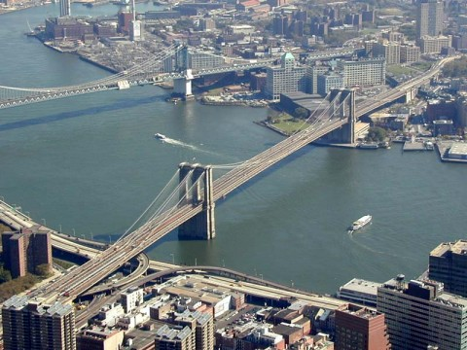

A bird’s eye view of Brooklyn Bridge overview

1. **Introduction**

The Brooklyn Bridge, a New York City landmark, spans 1825m across the East River in New York, connecting the boroughs of Brooklyn and Manhattan. When completed, it was the longest suspension bridge in the United States at the time of construction. It was 50% longer than any other. Lewis Mumford, an American historian of technology and science who is regarded as the leading 20th century authority on cities — their history, design and communal purpose, describes the Brooklyn Bridge “is still perhaps not only the most satisfactory object of Nineteenth Century engineering in America, but one of the best that can be shown anywhere.” (Mumford)

Although this project took a total of 13 years to complete (January 2, 1871 – May 24, 1883), and the cost is over $15 million, more than twice budget, it is still regarded an enduring monument of brilliant project management. The reason is that it created a lot of firsts. It was the first suspension bridge that made use of steel for the cable wire and the first to use explosives inside high pressure caissons, to create the foundations for the two towers. It was the first bridge which extended this length in that era. Especially, the chief engineer who is in charge of the bridge, John Augustus Roebling, also designed the bridge to be six times as strong as it needed to be. For these reasons the building project was complex and dangerous. 27 people died during construction including Roebling himself. His son, Washington, took over the project, but also became ill with decompression sickness (the “bends”) and had to rely on his wife Emily to oversee the building. However, they had overcome these and the Brooklyn Bridge stands out as perhaps the most famous and most remarkable in 1800s. Further later, due to its success, more bridges such as Williamsburg and Queensboro were built to connect with New York and Brooklyn.

1. **objective**

With the development of economy and the progress of society, Brooklyn became a big city in late of 1800s and raked among the top five largest cities in America. There were more than 5,000 factories (America Icon). More and more people used to commute between New York and Brooklyn. In 1860, 32 million passengers used the East River ferries; by 1868 the number was more than 50 million. Thirteen ferry boats completed more than one thousand crossings each day.

As we know, the shortest trip between these two cities was crossing the East river but it was not during the winter because the frozen East River was impossible to cross by boat. In the mid-1860s, it took less time to go from the state capital of Albany to New York City by train than to go from Brooklyn to Manhattan. People were so eager to build a bridge which would enable a faster traffic cross the river, regardless of weather conditions.

Talk of somehow bridging the East River began as early as 1800, when building a large bridge over the East River was almost impossible. The complex surroundings of the river let it be very difficult to achieve. Despite its name, the East River wasn’t really a river. It is actually a salt water estuary, prone to turbulence and tidal conditions. The water surface is from 800m to 5,600m, the deep is from 80 feet to 92 feet and there are many types of sediment in the deposit because of tides. The most complicating thing was the East River was very busy. Every moment, hundreds of crafts of all sizes sailed on it. The fact requested the designed bridge should be enough high to allow the largest ships to pass under it. If it was a suspension bridge, it would have to be the largest bridge ever built, nearly twice the length of the famed Menai Suspension Bridge, which had heralded the age of great suspension bridges when it opened in 1826.

1. **Project: build a suspension bridge**
   1. **Stakeholders**

In this case, stakeholders are the public which include the government from nation, state to New York and Brooklyn and the resident from these two cities; private organizer who got the charter to build this bridge, New York Bridge Company; chief engineers, John Roebling and his son, Washington Roebling.

Because of the traffic need between New York and Brooklyn, Henry Murphy, the lawyer, former politician, and owner of the Brooklyn Eagle found this opportunity and wanted to bridge the East River. In his time, it was not surprise that a private organization could undertake a public work. Hence, Henry Murphy culled 38 celebrities from different fields to form the New York Bridge Company to seek support for construction and financing. They petitioned the state legislature for a charter. On 1866 December 21, this act was passed. The legislation fixed the capital stock at five million dollars to build this bridge (The Great East River Bridge). According to bridge historian David McCullough, the New York Bridge Company got the chart and "was to have the power to purchase any real estate for the bridge and its approaches and to fix tolls." In later years, with this project’s developing, the public grew more knowledgeable about both bridge construction and business and they began to doubt ambiguous powers of the New York Bridge Company. On 1874 June 5, another act was passed authorizing New York and Brooklyn to assume control of the Brooklyn Bridge. The Bridge is placed under the management of a board of trustees, ten from each city including both mayors and comptrollers. Brooklyn is to raise two thirds of the funds; New York one third. The bridge thus becomes a public work.

We cannot judge this change is good or not but the face is too many conflicting parties were involved in this project. The suburbs of Brooklyn, the business district of Manhattan, adding the private New York Bridge Company, began to fight with each other for their own benefits. The result was the chief engineer had to worry about the financing of the bridge. Financing was not always received according to the project plan which not only made completion of the project to any sort of schedule difficult, it also increased the cost of the project.

Now we came back to 1867. On May 23, the company appointed John Roebling as chief engineer in charge of construction with salary $8,000 per year. Unfortunately, John was only involved in the initial planning stage. When he was making observations to determine the exact location of the Brooklyn tower, his foot was smashed in a freak accident. On 1969 July 22, he died of tetanus. His son, Washington Roebling took over his duty. That year, Washington Roebling was 32 years old. When that happened, Washington said, "Suddenly in charge of the most stupendous engineering structure of the age, with only preparatory plans, nothing fixed or decided. The prop on which I hitherto leaned had fallen. Henceforth, I must rely on myself" (Maher).

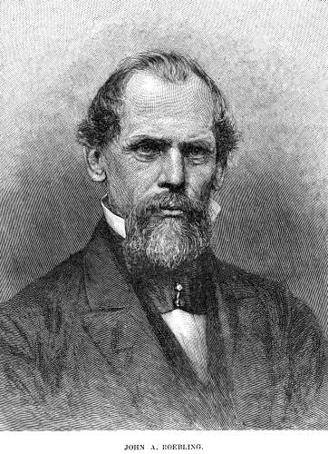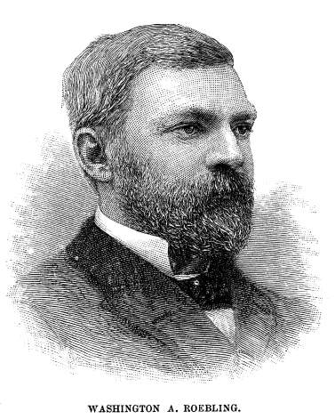

John Roebling (Figure by Harper’s Monthly) Washington Roebling

* 1. **Planning**

To be frank, Brooklyn Bridge’s success is the result of good planning by the Roeblings.

After John Roebling had been awarded the title of chief engineer, he worked out every detail of the bridge, from its foundations to the deck and steel cables. On 1867 September 1, John Reobling submitted a formal bridge proposal to the New York Bridge Company and the plan was subsequently approved (The Great East River Bridge). In his blueprint, Roebling listed a lot of details how to build this suspension bridge,

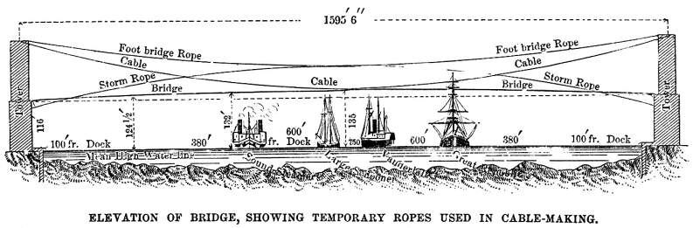(Figure by Harper’s Monthly)

* Length of river span: 1595.5 feet
* Total length of bridge: 5989 feet
* Width of bridge floor: 85 feet
* Suspension cables: four, each: 15.75 inches in diameter and 3578.5 feet long, containing 5434 wires each, for a total length of 3515 miles of wire per cable
* Foundation depth below high water: Brooklyn: 44 feet 6 inches  
  Foundation depth below high water, Manhattan: 78 feet 6 inches
* Buttressed gothic towers’ material: Granite
* Foundation depth below high water, 276 feet 6 inches  
  Roadway height above high water: 119 feet (at towers)
* Total weight, not including masonry: 14,680 tons

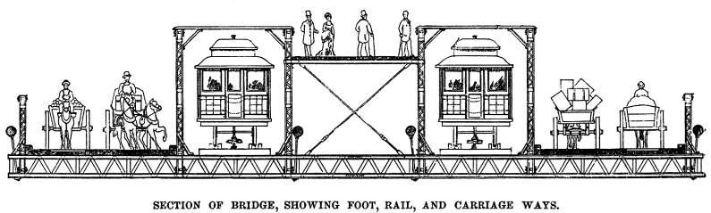(Figure by Paul Phillipe Cret and Rudolphe Modjeski.)

The most impressive thing is the bridge’s cable. The roadway platform was to be hung on two-inch diameter steel suspenders strung from two pairs of cables, 16 inches in diameter. Each cable was composed of 5,296 steel wires. John wanted these cable to bear the weight of 12,000 tons.

He said in his plan, “the contemplated work, when constructed in accordance with my design, will not only be the greatest bridge in existence, but it will be the great engineering work of the Continent and of the age. Its most conspicuous feature – the great towers – will serve as landmarks to the adjoining cities, and they will be entitled to be ranked as national monuments. As a great work of art, and a successful specimen of advanced bridge engineering, the structure will forever testify to the energy, enterprise, and wealth of that community which shall secure its erection.” (The Great East River Bridge)

John estimating this project would last 5 years and the cost $10,800,000 in which $7,000,000 would be the spent on the bridge and $3,800,000 on the land required.

Finally, to guarantee congressional approval, Roebling organized three Army engineers who were appointed by the government to report any general problems in the projects and particularly examine whether the bridge would be an obstruction to navigation.

Even though the Brooklyn Bridge project had the support from the government, it took two years for the project to be funded. On June 21 1869, the New York City Council and the Army Corps of Engineers finally approved Roebling’s plan and location of the Bridge. President Ulysses S. Grant subsequently signs a Federal bill passed by Congress to the same effect. (The Great East River Bridge)

* 1. **Launching**

Brooklyn Bridge Project began on 1870 January 3. According to the plan, this project would build towers, Brooklyn first and New York next. Then, cables would be draw cross the river. Finally, roadway on the bridge would be build.

*The book, The Great East River Bridge, 1883–1983* just marked the most important data for the project.

* 1870 January 3: Work on the Bridge begins.
* 1870 March 19: The caisson for the Brooklyn tower is launched (and is finally filled and finished on March 11, 1871).
* 1871 May 18: The New York caisson is launched (and is filled and finished by May 1872).
* 1875 May: The Brooklyn tower is completed.
* 1876 July: The New York tower is completed
* 1877 February 9: A temporary footbridge between the towers is completed and crossed.
* 1877 May 29: The first cable wire is drawn across the river.
* 1878 October 5: The last wire is drawn across the river.
* 1883 May 24: The Brooklyn Bridge is formally opened and dedicated.

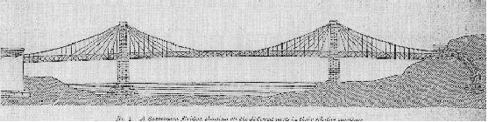

(Line drawing of the Brooklyn Bridge by master mechanic E.F. Farrington from "Concise Description of the East River Bridge," published by C.D. Wynkoop Printers, 1881.)

* 1. **Monitoring and Controlling**

In general, the construction industry is more challenging than other industries due to: every project is one-of a kind; many conflicting parties are involved; projects are constrained by time, money and quality; and high risk. This project is no exception. It is unique. It was first suspension bridge more than 500 meters at that time. John had no example to follow up. On its project management risk, the duration was 5 years means many changes. Any accident would lead delay the time. The organization risk is the project involved more than 2,500 workers and many departments. Besides, it was an outside project and weather was another important factor.

1. **Risk: Founding**

Believe it or not, the foundation for these towers is the most difficult part of the whole project implementation. To cross a river 1,600 feet in width with a single span had, up to this time, been though beyond the limits of engineering skill. By the way, the government had many strict requirements to this project. When the plan was approved, the government requested an increase of 1.8 meters in height at the mid span and its height would reach to 48.6 meters. At the same time, it was also required to widen the bridge from 28.8 meters to 30.6 meters. Besides this change, ships should go through the river normally even building the foundation. These all need the chief engineer to find a solution for the foundation, how to dig a bigger, deeper hole and anchor the towers on solid bedrock.

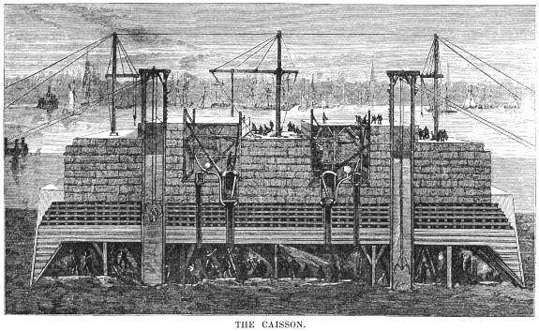(Figure by Harper’s Monthly)

The Roeblings’ choice was using caisson, the method of working by compressed air. The Roeblings had learned this method in Europe and there was a great success example in St. Louis (The East River Suspension-Bridge). However, the length of Brooklyn Bridge was longer than that one. The concrete procedure of the Caisson is: Each tower was built on the top of a huge watertight chamber which was called a pneumatic caisson. Caisson is a hollow wooden box with V-shaped sides, without bottoms and a solid roof of interlocking courses of timber. The caisson was built and assembled on land and then put into the river. Compressed air was pumped into the caisson to prevent entering water. Workers entered the chamber through air locks and dig away at the riverbed to force the caisson ever deeper. When the caisson reached ground firm enough to support the whole weight of the tower, it was filled with concrete. The stone towers were built atop the caissons, which sank deeper into the river bottom.

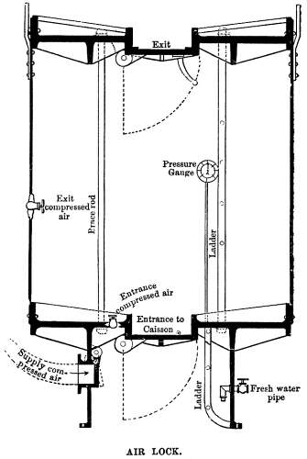

(Figure by Harper’s Monthly)

However, Washington never thought that working in the caissons was so hard and dangerous because the air in the caisson’s chamber is enormous harm. In the article “In Sandhog: Building the Brooklyn Bridge, 1871,” published on website Eyewitness to History, working conditions were vividly described. They were likened to Dante’s Inferno. Here’s an account of what they were like: “The tremendous pressure, the suffocating heat, the lack of oxygen and the noise all combined to limit a worker’s time within the caisson to a maximum of two hours.” Horrible environment led more than one hundred people got Caisson’s disease--which is caused by changes in air pressure that affect nitrogen levels in the bloodstream. A case of this disease nearly killed Washington Roebling himself. He survived, but became crippled, confined to his house for the remainder of his life (Maher).

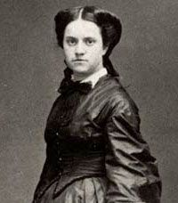

Emily Roebling (Figure by Harper’s Monthly)

With the assistance of his wife Emily, Roebling used a telescope to observe the construction of the bridge from his apartment. He dictated instructions to his wife, who relayed the orders to the workers. Emily taught herself to be a combination engineer and project manager. She studied higher mathematics and bridge engineering and visited the construction site every day in order to supervise her husband’s staff of engineers and builders.

One of their great corporations was changing the depth of the Manhattan caisson to hit the river bed. According the plan, the Brooklyn caisson hit bedrock after around 44 feet and was filled with concrete to create the base. The Manhattan caisson was much more dangerous. The plan was originally to lower it 106 feet to hit the bedrock, but as they got lower and lower, and the dangers became more apparent. Washington Roebling made probably the riskiest decision of the entire construction. By taking soil samples he discovered that the soil hadn't shifted in millions of years, and so he decided that it was stable enough itself to hold the bridge. Now, the caisson on the Manhattan side is 78 feet below water and rest on sand.

1. **Human Resource**

Build this bridge is a huge project. When initialing this project, Kinglsey & Keeney Contractor Firm was assigned to concentrate on hiring the work force. At any given day, there were about 600 men working on the bridge. More than 2,500 men were involved in the work in the caissons.

Most of these workers were new immigrants who came from Irish, Italian, German, and Russian. They earned $2 a day at first. After hitting twenty-eight feet, the wage increased to $2.25 (McCullough).

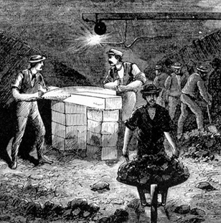

Inside the caisson (Figure by American Icon)

When working inside the caissons, horrible conditions caused an average of 100 men to quit in a week. They were bothered by sicknesses that included smallpox, typhoid, malaria, yellow fever, cholera, and tuberculosis were spreading rapidly throughout the increasing population of New York City (Immigrants, Cities and diseases: immigration and health concerns in late nineteenth century America). Moreover, they fought with Caisson’s disease which we discussed earlier on this page. When the workers worked in the New York caisson, the pressure reached more than thirty-five pounds per square inch. No one knew its dangerous and how to protect themselves. They just ate more and drunk a lot (McCullough). Still, nothing worked.

And by and by the workers realized the hazards and undesirability of their work, finally struck. They demanded $3 for a four-hour workday. After negotiating, the wage became $2.75 per day (McCullough).

Not to mince matters, the working conditions for this project were very hard and terrible. Because of these conditions, this only let them work in the caisson for a maximum of two hours. Many events slowed down the workers timing and building. Twenty seven men died as a result of fires, explosions and caisson’s disease, including John Roebling (Brooklyn Bridge Opens). In his speech, Congressman Abram S. Hewitt, later elected mayor of New York, says, “When we turn to the graceful structure at whose portals we stand, and when the airy outline of its curves and beauty, pendent between massive towers suggestive of art alone, is contrasted with the over-reaching vault of heaven above and the ever-moving flood of waters beneath we are irresistibly moved to exclaim, ‘What hath man wrought!’”(The Great East River Bridge)

1. **Years of Construction and Rising Costs**

After the caissons had been sunk to the river bottom, they were filled with concrete, and the construction of the stone towers continued above. When the towers reached their ultimate height, 278 feet above high water, work began on the four enormous cables that would support the roadway.

Spinning the cables between the towers began in the summer of 1877, and was finished on 1878 October 5. But it would take nearly another five years to suspend the roadway from the cables and have the bridge ready for traffic.

By the time it was finished in 1883, the bridge had cost about $15 million, more than twice what John Roebling had originally estimated. Why the time was late and the cost went up for the Brooklyn Bridge Project?

The first reason was the original plan’s changes from the Government. In order to adapt the increasing volume of inter-urban commerce and the rapid growth of cities, the Government listed new requirements. One of them was an increase of 1.8 meters in height at the central clearance of the bridge to 48.6 meters. Another was to widen the bridge from 28.8 meters to 30.6 meters. Those meant the chief engineer needed to change a lot, including superstructure, towers, foundations and anchorages. Then, the total cost increased 8 percent due to these changes. Furthermore, in order to strengthen the bridge, John Roebling decided to use steel instead of iron in the construction of both the cables and the suspender superstructure. This replacement cost $2,000,000, which covers the excess in cost on the bridge proper. The United States government also decided to connect the system of rapid transit of New York and Brooklyn. The new station building and elevated railway structures were to be built on the approaches (Harper’s Monthly).

The second reason was there were many unanticipated costs. To get a deeper foundation and not effect by the traffic of the East River, the Roeblings chose using the Caisson. Although it was a good method, it had caused many problems and increased costs. One of them was the Caisson’s disease. Because of it, many people died. The workers began to strike and fight for their living rights. The result was their wages increased from $2 per day to $2.75. Another accident was recorder in the book, *from The Great East River Bridge, 1883–1983*. “On 1870 December 2, Fire in the Brooklyn caisson necessitates flooding of the caisson, delaying progress for almost three months and costing $15,000.” Fire, explosion and bad weather all caused cost increasing and delaying the time.

The third one is some scandals. Since this project was a public work, someone always tried to get some benefits from it. We never know the exact number for this part of cost. In one famous case which was reported, the J. Lloyd Haigh Company that was responsible for providing wire for the cables was found to have given faulty wires. It was impossible at the time to replace these bad wires. 150 extra wires were added to each cable to strengthen them. That was another extra cost. John Roebling designed this bridge to be six times stronger than it needed to be. Now, it is only about four times stronger than it needed to be, due to the inferior wire supplied by J. Lloyd Haigh.

The above changes and additional items were not originally contemplated, and they totally swelled the cost of the bridge by five million. On 1878 November, the Bridge Project was interrupted by lack of funds. Until the day on 1882 June 29, the project restarted. The Legislature directs that the cities of New York and Brooklyn pay to the trustees of the Brooklyn Bridge the sum of $1.25 million “or so much thereof as shall be necessary to complete the Bridge in the proportion of one third from New York and two thirds from Brooklyn.”(The Great East River Bridge)

* 1. **Closing**

Finally, the construction of the bridge was complete. The Brooklyn Bridge has two (276 feet) towers made of limestone and granite, two Anchorages, four Supporting cables, seven traffic lanes which 4 for Carriages, 2 for Trains and 1 Promenade. Here is the data of Brooklyn Bridge from U.S. Department of Transportation.

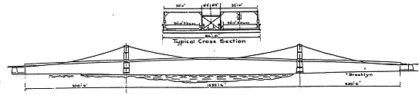

* Construction of masonry commenced - Jan 3, 1870
* Construction of steel work commenced - May 28, 1877
* Opened to traffic - May 24, 1883
* Total length - 6016 feet
* Length of main span - 1395½ feet
* Length of each of the four cables - 3578½ feet
* Diameter of each cable - 15¾ inches
* Total number of wires in each cable - 5296
* Total length of wire in the four cables - 14,357 miles
* The clear height over river channel is 133 ft. above mean high water
* Height of towers - 272 ft. above mean high water
* Total weight of steel and iron in bridge & approaches - 24,000 tons
* Cost of construction of bridge - $17,909,412.44
* Cost of Land - $7,185,165.00
* Total Cost $25,094,577.44

On 1883 May 24, The Brooklyn Bridge was formally opened. On the first day of its opening, a total of 1,800 vehicles and 150,300 people crossed the bridge (Maher). In 1884, entrepreneur P.T. Barnum demonstrated the safety of the bridge by parading across it with a herd of 21 elephants.

1. **Assessment**

The Brooklyn Bridge had used fourteen years to complete. The total cost is over $25 million, the equivalent to $700 million in 2014. For this point, this project was not a success. However, today, it is praised as a brilliant, groundbreaking project because this bridge created so many first and let an impossible thing become a fact. Before the Brooklyn Bridge was built, the idea had discussed more than fifty years and many plans had never been approved. No one could build so long bridge except John Roebling. He created a new system to build this bridge. In the research paper of “The Roeblings and the Stayed Suspension Bridge: Its Development and Propagation in Nineteenth-Century United States”, Stephen Buonopane, a professor of Civil & Environmental Engineering, explains this system with professional terms. “John Roebling developed a hybrid structural system for his suspension bridges, consisting of three primary elements - parabolic suspension cables, inclined (or diagonal) cable stays and stiffening trusses.” Roebling was not first one to use any one of these system but he was the first one to combine them successfully. To guarantee the Brooklyn Bridge’s firmness, it used steel cables. Most of the bridges that were built around the same time have collapsed or have been replaced. With diligent maintenance, it’s still likely a new one. As we know, inheriting tradition is very easy but having own innovation is very hard. During the construction of the bridge, Washington Roebling had met lots of difficulties, such as the conflicts with Governments, lack of money, worker strike and explosion, fire accidence. Even he crippled because of the Caisson disease, he never gave up. His effort allowed the bridge to be the longest spans in the world, and at the same time overcome many of the problems of flexibility associated with 19th century suspension bridges. This bridge became a “trademark” of Roebling design in the late 19th century, and other bridge designers in the United States adopted this structural form.

My simulation project is Thanksgiving dinner. Honestly, it is a challenge for me because my husband and I are Chinese and we have never cooked a turkey before. It was not in our cooking list. This situation just likes to build the Brooklyn Bridge. It is first longest suspension bridge in the United States at that time. The chief engineer had no experience to build this so long suspension bridge. Just like us, we have not any experience either to toast a turkey. The key point to solve this problem is to find a right example to follow up. The chief engineer of the Brooklyn Bridge, John Roebling chose Caisson to build the bridge’s foundation. He learned this method in Europe and there were so many successful examples. To me, I can use google to search a turkey’s recipe or ask other people. Finally, I asked one of my American friends to get the recipe when I make the dinner plan.

However, this plan can be changed anytime if you think it is necessary. In fact, the plan was changed a lot when the Brooklyn Bridge was built. For example, the original plan requested the Manhattan caisson was below the water surface 106 feet. Because more deep means more dangers and the chief engineer found the soil had not shifted in millions of years by taking soil samples, the foundation on the Manhattan side is only 78 feet deep. To my dinner party project, I faced some changes too. Before I started to shop materials, one of my husband’s co-workers gave us a new turkey’s recipe. The new one will skip the process to brine the turkey. Then, ask us to put some kind of soup & dip mix inside the turkey bag, use Chinese bacon and Chinese sweet rice as the turkey’s stuff. Because this co-worker and our guests are all Chinese, we just thought this recipe would be the right one. We decided to change the plan. At the same time, my husband suggested us to cancel the contingency plan which was grilled lamb chops with cumin. He said that maybe someone would not like to eat turkey since it was not Chinese typical food. We should have two main courses at that night. If we cooked a smaller turkey and used fish to replace lamb in order to skip the process to brine the lamb, we would short 12 hours and our guest would have more choices to eat. After discussing, we chose the new one. The result is the time was shorted, the cost was lower than the budget and the food was very delicious. As it happened, one of our guests did not like turkey and she ate the fish a lot.

Through writing this paper, learning this course and doing the dinner party project, I start to know a word, the change. As we know, projects and programs by their very nature create change. You should not be afraid the change. If you know how to manage it, it will bring you benefits and no harm.

*Work Cite:*

Maher, James, ed. *Brooklyn Bridge*. jamesmaherphotography.com, 2013. Web. 23 Oct. 2014.

   <http://www.jamesmaherphotography.com/articles/26-brooklyn-bridge>.

Lewis Mumford, “The Brooklyn Bridge,” *American Mercury* 23 (August 1931)

“American Icon: Incorporating Tensions in the Brooklyn Bridge” <http://xroads.virginia.edu/~MA03/pricola/bridge/print.html>

United States Department of Transportation. “Managing the East River Bridges in New York City”

Brooklyn Bridge. Dir. Ken Burns. Perf. Paul Goldberger, David McCullough, Arthur Miller, and Lewis Mumford. PBS, 1981.

"Brooklyn Bridge"NYCityRoads.com. Ed. Steve Anderson. 1996. 25 Feb. 2003..

The Brooklyn Museum.The Great East River Bridge, 1883-1983. New York: Abrams, 1983.

McCullough, David.The Great Bridge: The Epic Story of the Building of the Brooklyn Bridge. New York: Simon and Schuster, 1972.

Harper’s Monthly, The Brooklyn Brideg.New York: 1883

America Illustrated, The East River Suspension-Bridge: 1877

Immigrants, cities, and disease: immigration and health concerns in late nineteenth century America. US History Scene, 13 Aug. 2012. Web. 23 Oct. 2014. <http://www.ushistoryscene.com/

Kingsley, William C., Seth Low, and Franklin Edson. "Opening Ceremonies of the New York and Brooklyn Bridge, May 24, 1883." Opening Ceremonies of the New York and Brooklyn Bridge, May 24, 1883. Project Gutenberg Literary Archive Foundation, 2010. Web. . 23 Oct. 2014.

"Sandhog: Building the Brooklyn Bridge, 1871", EyeWitness to History, www.eyewitnesstohistory.com (2005).

Stephen Buonopane, “The Roeblings and the Stayed Suspension Bridge: Its Development and Propagation in Nineteenth-Century United States”.